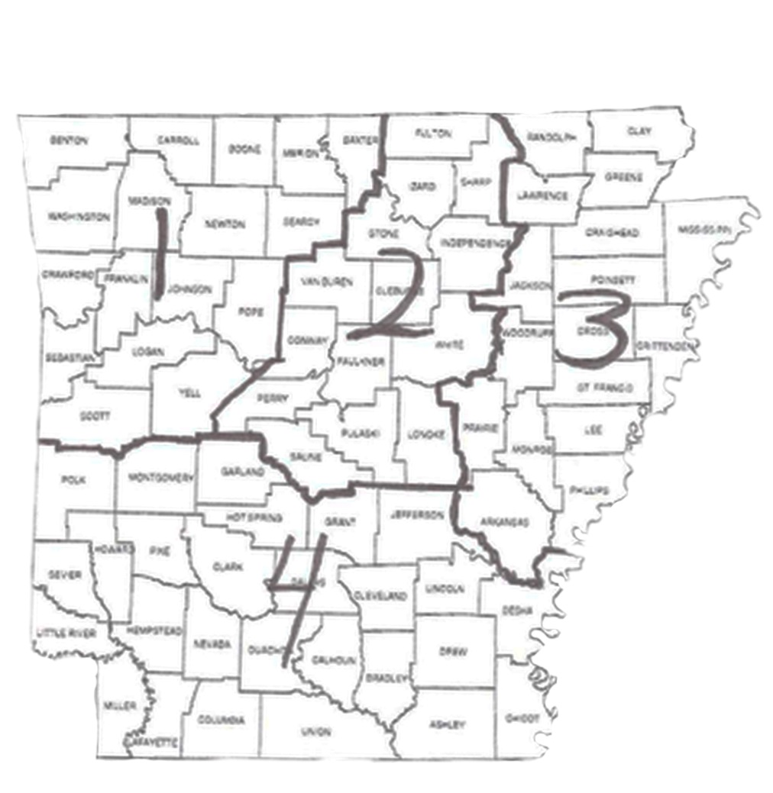
Appendix A

(The Appendix is not an official
document and may be changed
as needed by recommendation
of the ASO Executive Board.)

ASO Areas

AREA 1: Counties: Baxter, Benton, Boone, Carroll, Crawford, Franklin, Johnson, Logan, Madison, Marion, Newton, Pope, Scott, Searcy, Sebastian, Washington, Yell
Chapters: Iota - Fayetteville, Chi - Harrison, Alpha Theta - Charleston, Alpha PI – Ft. Smith, Alpha Rho – Van Buren, Beta Nu - Russellville, Beta Pi - Rogers, Beta Sigma – Bentonville, Beta Tau - Greenwood, Gamma Eta - Yellville, Gamma Iota – Fayetteville
AREA 2: Counties: Cleburne, Conway, Faulkner, Fulton, Independence, Izard, Lonoke, Perry, Pulaski, Saline, Sharp, Stone, Van Buren, White
Chapters: Gamma – Little Rock, Theta - Conway, Mu - Benton, Alpha Mu -Little Rock, Alpha Sigma - Morrilton, Beta Beta - Beebe, Beta Lambda – Little Rock, Beta Xi – Heber Springs, Beta Upsilon - Salem, Beta Psi – Little Rock, Gamma Omicron – Little Rock
AREA 3: Counties: Arkansas, Clay, Craighead, Crittenden, Cross, Greene, Jackson, Lawrence, Lee, Mississippi, Monroe, Phillips, Poinsett, Prairie, Randolph, Woodruff
Chapters: Zeta – Blytheville, Sigma – Augusta/Des Arc, Omega - Marianna, Alpha Alpha – Helena/West Helena, Beta Omega - Stuttgart, Gamma Theta – Brinkley, Gamma Rho – Jonesboro
AREA 4: Counties: Ashley, Bradley, Calhoun, Chicot, Clark, Cleveland, Columbia, Dallas, Desha, Drew, Garland, Grant, Hempstead, Hot Springs, Howard, Jefferson, Lafayette, Lincoln, Little River, Miller, Montgomery, Nevada, Ouachita, Pike, Polk, Sevier, Union
Chapters: Alpha – El Dorado, Delta must change name – Hot Springs, Lambda - Arkadelphia, Alpha Beta - Magnolia, Alpha Delta – Hope/Prescott, Alpha Kappa - Mena, Beta Epsilon must change name - Sheridan, Gamma Beta - Monticello, Gamma Sigma - Ashdown, Gamma Chi – Texarkana, Epsilon Beta – Pine Bluff

A chapter may appeal to the ASO Executive Board for approval to change from one area to another. See Arkansas State Organization Standing Rules 5.2 (Revised 2017)

Appendix B

ASO Editorial Practices

a. The Arkansas State Organization News and the website exist to inform, to inspire, to explore issues of concern to educators, and to record ASO events and issues. Because of space and time restrictions, the ASO editor and the ASO web master/liaison must select from submissions and make editorial and priority decisions according to the following standards:

1) Timely publicity for ASO events;
2) Reports of chapter programs and projects with significance beyond the chapter level;
3) Articles contributing to the personal and professional growth of members, promoting
educational expertise, or helping fulfill the Society's purposes.
4) Publication of obituaries only for state officers, past and present.

b. Chapter presidents and chapter communications chairs will receive guidelines each biennium for submitting items to Arkansas State Organization News and the ASO website. All members may submit articles or announcements, and the following guidelines are offered as general directions:

1) The person submitting an article should observe deadlines and send items by postal or electronic mail to the editor and/or the website supervisor.
2) The person submitting an article should include contact information (name, chapter, address, telephone number, email) and be sure that all names in the article are spelled correctly.
3) Submitted articles must be legible and accurate.
4) Members may submit electronic or print photographs of interest to ASO members.
5) All photographs should be labeled with the correct spelling of names and chapters. Accompanying the photograph should be a brief description of the event at which it was taken.

c. Comments and inquiries about Arkansas State Organization News and/or ASO website are welcome.

d. All members are encouraged to contribute articles, pictures, and opinions.

e. All executive board members shall be electronically notified when Arkansas State Organization News is published on the ASO website. Chapter presidents shall be responsible for notifying all chapter members.

Appendix C
Article Schedule for Arkansas State Organization News
EVEN NUMBERED YEARS |  |  | ODD NUMBERED YEARS
DEADLINE DATE | ISSUE DATE | Areas & Committees  REPORTING | DEADLINE DATE | ISSUE DATE | Areas & Committees  REPORTING
Dec 10 | Jan 1 | Areas 3 & 4  Expansion  Technology  Educational Legislation  Scholarship | Dec 10 | Jan 1 | Area 1  Expansion  Technology  Educational Legislation  Scholarship  Convention
Feb 10 | March 1 | All areas  Records & Properties  Leadership Development  Educational Excellence | Feb 10 | March 1 | Area 2  Records & Properties  Leadership Development  Educational Excellence  Convention
April 10 | May 1 | Areas 1 & 2 Membership  Technology  Educational Legislation | April 10 | May 1 | Area 3  Membership  Technology  Educational Legislation
June 10 | July 1 | All areas  Finance  Non-dues Revenue  Educational Excellence | June 10 | July 1 | Area 4  Finance  Non-dues Revenue  Educational Excellence  Convention  ASO Fall Meeting
Aug 10 | Sept 1 | Areas 1 & 3  Communication  Rules  Technology  Scholarship  ASO Fall Meeting | Aug 10 | Sept 1 | Areas 2 & 4  Communication  Rules  Technology  Scholarship  ASO Fall Meeting
Oct 10 | Nov 1 | Areas 2 & 4  Nominations  Personnel  Awards  Ed. Excellence  ASO Fall Meeting | Oct 10 | Nov 1 | Areas 1 & 3  Nominations  Personnel  Awards  Educational Excellence  ASO Fall Meeting

Appendix D
General Information & Practices

President pin and expression of appreciation
- The state/chapter treasurer orders the president’s pin.
- The immediate past president presents the president’s pin to the incoming president
- The state immediate past president selects a token of appreciation for the retiring president—paid for from budgeted funds for administrative expenses.

Names of Arkansas State Scholarships
- Dr. Flora M. Gillentine/Ida Ruth Reeves
- Hazel L. Dabney/ Gladys E. Johnson McDaniel
- Elizabeth Buck/ Lois W. Thomas
- Claire T. White

Agatha Prator
The Agatha Prator Grant is awarded each semester (fall/ spring) to a pre-service educator in the student teaching semester (either as a senior or as an intern) and who is an Arkansas resident (or a resident of Texarkana, TX). The grant fund is an endowment from Agatha Prator and is administered by the Arkansas Community Foundation. Prator was Alaska state organization president before relocating to Texarkana and becoming a Kappa State member.

Term for Executive Secretary
The term of the executive secretary is intended to begin in the second year of a president’s biennium to facilitate continuity and efficiency.

Source of Officer Training Fund
The Officer Training Fund is a non-dues revenue savings account established with monies generated by the membership through fund-raising activities for hosting the 2002 International Convention and the 2009 Southeast Regional Conference.

Definition of grant-in-aid and scholarship
The proper use of the terms grant-in-aid and scholarship is determined by the source of the money that funds them. Grant-in-aid, in general, represents awards supported by funds other than the scholarship fee.

Committee notification of applicants
A committee that makes selections from submitted applications should notify recipients and non-recipients of the selections.

Appendix E
Mission, Vision, Purposes, DKG Song
Mission
The Delta Kappa Gamma Society International promotes professional and personal growth of women educators and excellence in education.
Vision
Leading women educators impacting education worldwide.
Purposes
The Delta Kappa Gamma Society International has seven basic purposes that govern its program of work and study. The activities of each level of the Society implement the purposes of the Society. The seven purposes include
1. To unite women educators of the world in a genuine spiritual fellowship
2. To honor women who have given or who evidence a potential for distinctive service in any field of education
3. To advance the professional interest and position of women in education
4. To initiate, endorse and support desirable legislation or other suitable endeavors in the interests of education and of women educators
5. To endow scholarships to aid outstanding women educators in pursuing graduate study and to grant fellowships to non-member women educators
6. To stimulate the personal and professional growth of members and to encourage their participation in appropriate programs of action
7. To inform the members of current economic, social, political and educational issues so that they may participate effectively in a world society

THE DELTA KAPPA GAMMA SONG (Tune: “Men of Harlech”)

Women teachers, to the calling  Firmly rally, never falling.  Duty ne’er upon us palling.  Staunch, courageous, we,  Loyalty and trust e’er heeding,  Mindful of our sisters needing  Aid and guidance from those leading,  Helpful may we be!  To Delta Kappa Gamma  Faith we pledge forever!  Hand in hand, our loyal band,  Forward moving ever!  Onward! ‘Tis our sisters need us,  Courage, Faith, and Honor lead us!  Wrongs in truth and justice heed us!  Firmly shall we stand! | Guardians of the faith yet sleeping  For our sisters watch e’er keeping,  Deeds of others now we’re reaping,  We for others stand!  To us pioneers have given;  We return their gifts to Heaven;  Work for others is the leaven  That in inspires our band!  Oh, Delta Kappa Gamma  In thy fold we gather;  Unity and Liberty  Shall be our watchwords ever!  Education e’er we’ll further;  Each is bound to each as brother;  With this faith in one another  We shall win, for aye!

Appendix F

Schedule for Area Representatives serving on Personnel Committee

Areas | Elected | Term of Office | Chairman
2 and 4 | Area Meeting 2016 | 2017 – 2021 | Area 4 2019 – 2021
1 and 3 | Area Meeting 2018 | 2019 – 2023 | Area 1 2021 – 2023
2 and 4 | Area Meeting 2020 | 2021 – 2025 | Area 2 2023 – 2025
1 and 3 | Area Meeting 2022 | 2023 – 2027 | Area 3 2025 – 2027
2 and 4 | Area Meeting 2024 | 2025 –2029 | Area 4 2027 --2029
1 and 3 | Area Meeting 2026 | 2027 –2031 | Area 1 2029 --2031

